|  |  |  |  |  |  |  |
| --- | --- | --- | --- | --- | --- | --- |
| Gantt Chart | | | | | | |
|  | Week 3 | Week 4 | Week 5 | Week 6 | Week 7 | Week 8 |
| Planning |  |  |  |  |  |  |
| Decomposing – Fonts, colours, images |  |  |  |  |  |  |
| Trial of Components - Wireframe |  |  |  |  |  |  |
| Feedback on trialing |  |  |  |  |  |  |
| Testing final outcome (iteratively) |  |  |  |  |  |  |
| Describe and Address Implications |  |  |  |  |  |  |
|  |  |  |  |  |  |  |
| Coding website (1.4) |  |  |  |  |  |  |
| Final Write up(on going) |  |  |  |  |  |  |
|  |  |  |  |  |  |  |

**1.8 Plan:**

17/5

Breakdown of Outcome:

A website is a set of related webpages linked together with a single domain. On a website you can display information such people, events, clubs or activities.

What makes a good website?

* Easy navigation.
* A clear and strong message. Users should easily be able to get the purpose of the website, and the message.
* Shows relevant content.
* Shows consistency throughout the pages. Example: Same colours, same logo.
* Uses original content.
* Speed-Loads at a good speed, downloads download quickly.
* Use visual hierarchy-Main titles use h1, sub titles use h2 or h3.
* Should be easy to maintain.
* Always up-to-date.

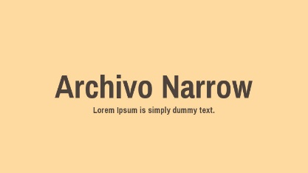Fonts I could use:

Sans serif

Archivo Narrow 🡪



Anton 🡪

I decided to use Archivo Narrow as my font. This is because it looks good on my website, and its easy to import into my website.

Colours: Red, Gold

Hex colours: Red=#8B1A1C, Gold=#FEBF58

Color study: <https://negliadesign.com/ask-a-designer/whats-the-difference-between-pms-cmyk-rgb-and-hex/>

Logo:



Website layout examples:

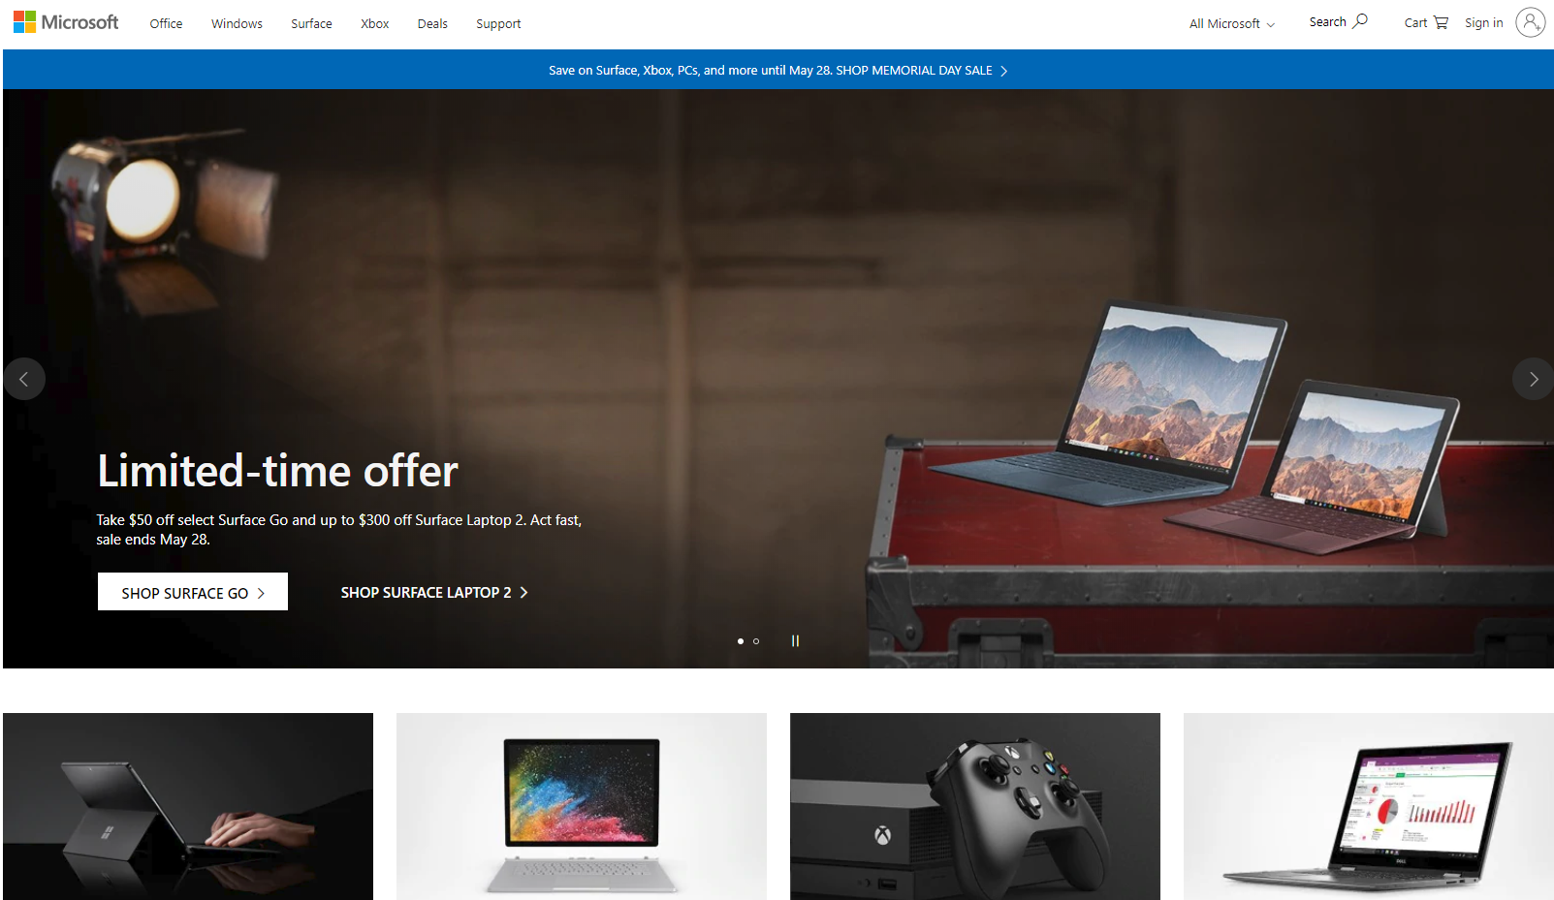

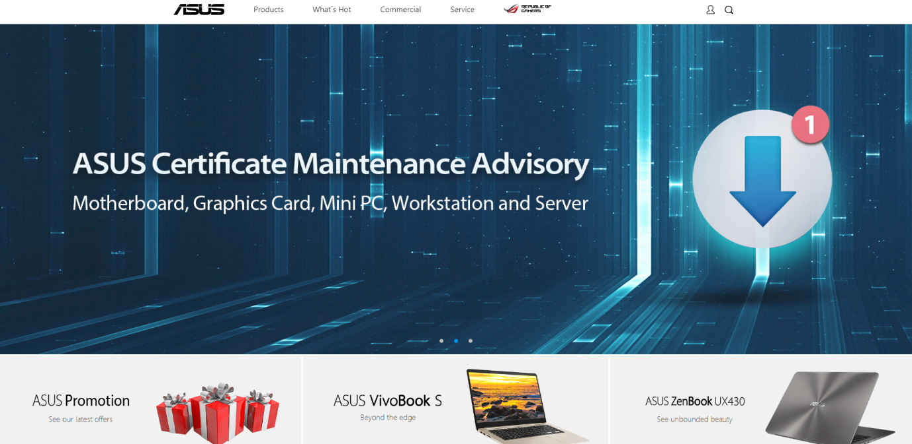

Daily Log 17/5: Started the Breakdown of Outcome, went over colours and some fonts

Daily Log 20/5: Went over better fonts

Daily Log 21/5: Sorted out what the website will be about

Daily Log 27/5: Got examples of website designs I could base my website off.

Daily Log 28/5: Made a wireframe, based on the Microsoft website.

Daily Log 13/6: Worked on website navigation bar

Daily Log 21/6: Fixed slideshow, trying to figure out how to put logo beside title